Adaptive ImpRAG: Efficient Retrieval-Augmented Generation with Iterative Retrieval and Dynamic Layer Allocation
Capstone Project Proposal
Submitted by:
(102303142) NOOR TANDON
(102303144) ARSHIA ANAND
(102303370) KUNAL GUPTA
(102303519) SAMYAK RAWAT
(102317256) SAKSHAM GUPTA
BE Third Year- COE/ CSE
CPG No. 57
Under the Mentorship of
Dr. Nitin Arora
Assistant Professor - I
Dr. Vishal Mehra
Assistant Professor

Computer Science and Engineering Department
Thapar Institute of Engineering and Technology, Patiala
MARCH 2026

TABLE OF CONTENTS

Sr. No | Index | Page No
1. | Project Overview | 01
2. | Problem Statement | 02
3. | Need Analysis | 03
4. | Literature Survey | 04
5. | Objectives | 07
6. | Methodology | 08
7. | Work Plan | 11
8. | Project Outcomes and Individual Roles | 12
9. | Course Subjects | 13
10. | References | 15

Mentor Consent Form

I hereby agree to be the mentor of the following Capstone Project Team

Project Title: Adaptive ImpRAG: Efficient Retrieval-Augmented Generation with Iterative Retrieval and Dynamic Layer Allocation

Roll No | Name | Signatures
102303142 | Noor Tandon
102303144 | Arshia Anand
102303370 | Kunal Gupta
102303519 | Samyak Rawat
102317256 | Saksham Gupta

NAME of Mentor: ……… . . . . . . . . . . . . . . . . . . . . . . . . . . . . . . . . . . .
SIGNATURE of Mentor: . . . . . . . . . . . . . . . . . . . . . . . . . . . . . . . . . . . .

NAME of Co-Mentor: ……… . . . . . . . . . . . . . . . . . . . . . . . . . .
SIGNATURE of Co-Mentor: . . . . . . . . . . . . . . . . . . . . . . . . . . . . . . . .

PROJECT OVERVIEW

Large Language Models (LLMs) have demonstrated remarkable capabilities across a wide range of natural language tasks; however, they are fundamentally limited by the static knowledge encoded in their parameters at training time, making them prone to errors in knowledge-intensive tasks. Retrieval-Augmented Generation (RAG) was introduced to address this by integrating external knowledge retrieval with language model generation, improving factual accuracy and reducing hallucinations. Despite its effectiveness, traditional RAG architectures treat the retriever and generator as separate components, relying on explicitly designed queries that may not accurately reflect the model's true information needs, often resulting in a mismatch between retrieved content and what is actually required for generation. Recent efforts have sought to unify retrieval and generation within a single architecture.

Notably, Implicit Retrieval-Augmented Generation (ImpRAG) eliminates explicit query formulation by allowing the model to implicitly represent its information needs, dividing transformer layers into specialized groups for retrieval, reading, and generation. While this design improves alignment between retrieval and reasoning, it still suffers from key limitations, including single-pass retrieval that restricts multi-hop reasoning, high computational costs due to full fine-tuning, noisy retrieved passages, manual layer boundary tuning, and unreliable pseudo-label supervision from external retrievers. To overcome these challenges, this project proposes Adaptive ImpRAG, an enhanced framework that introduces iterative retrieval for multi-step knowledge acquisition, enabling the model to progressively refine information for complex queries.

To reduce computational overhead, the system employs parameter-efficient fine-tuning techniques, specifically LoRA and QLoRA, significantly reducing trainable parameters while maintaining strong performance. Further improvements include a document utility scoring module to filter irrelevant passages, a dynamic layer allocation mechanism that adaptively assigns layers based on query complexity, and improved retriever supervision using LLM-based relevance scoring and multi-retriever ensemble signals, collectively resulting in a more efficient, scalable, and accurate RAG system.

PROBLEM STATEMENT

Retrieval-Augmented Generation (RAG) has emerged as an effective paradigm for enhancing large language models (LLMs) with external knowledge. By retrieving relevant documents from external sources and incorporating them into the generation process, RAG improves factual accuracy and contextual grounding. However, most existing RAG systems rely on explicit query formulation and a fixed retrieve-then-generate pipeline, which limits adaptability and may lead to suboptimal retrieval when the query does not accurately represent the model’s information needs.

Recent research has proposed implicit retrieval frameworks that integrate retrieval and generation within a single architecture, allowing language models to internally represent their information requirements. While this improves coordination between retrieval and generation, several limitations remain. Many systems rely on single-pass retrieval, restricting their ability to perform multi-step reasoning. In addition, full fine-tuning of large models introduces high computational cost, and retrieved documents may include irrelevant information that reduces response quality.

To address these challenges, this project proposes Adaptive ImpRAG, an improved retrieval-augmented generation framework. The proposed system introduces an iterative retrieval mechanism that enables multi-step information acquisition during generation. To reduce computational overhead, the framework incorporates parameter-efficient fine-tuning methods such as Low-Rank Adaptation (LoRA) and Quantized Low-Rank Adaptation (QLoRA) to reduce the number of trainable parameters while maintaining performance.

Additionally, the system includes a document utility scoring module to filter irrelevant documents and a dynamic layer allocation strategy that adjusts retrieval and generation layers based on query complexity. Improved retriever supervision using LLM-based relevance scoring and multi-retriever ensemble signals is also explored to provide better training feedback. These improvements aim to enhance retrieval accuracy, reduce computational cost, and improve scalability across knowledge-intensive tasks.

NEED ANALYSIS

Large Language Models (LLMs) have achieved significant success in natural language processing tasks such as question answering, summarization, and conversational AI. However, they rely on knowledge embedded during training, which remains static and often leads to outdated or hallucinated responses. This limitation poses serious risks in high-stakes domains such as medical diagnosis support, legal analysis, and scientific research, where misinformation can have significant consequences. Retrieval-Augmented Generation (RAG) addresses this by integrating external knowledge sources, improving factual accuracy and contextual grounding. Traditional RAG systems follow a retrieve-then-generate pipeline, where a query is constructed from the input prompt to retrieve relevant documents before response generation.

While effective, this approach depends heavily on query quality and retriever–model alignment. If the query fails to represent the true information need, irrelevant documents may be retrieved, degrading response accuracy. Recent approaches such as ImpRAG improve this by integrating retrieval and generation within a unified architecture. However, they still rely on single-pass retrieval, limiting their ability to perform multi-hop reasoning for complex queries. Computational feasibility presents another major challenge. Full fine-tuning of large transformer models requires significant memory and processing resources, making deployment impractical in resource-constrained environments. Although parameter-efficient techniques such as LoRA and QLoRA reduce training costs, retrieval quality remains a concern. Retrieved document sets often contain noisy or irrelevant information, introducing misleading context and reducing output reliability. Additionally, existing architectures rely on fixed layer configurations, which lack flexibility to adapt to varying query complexity and result in inefficient resource utilization.

These limitations highlight the need for a more adaptive, efficient, and scalable retrieval-augmented generation framework. The proposed Adaptive ImpRAG system addresses these challenges by enabling iterative retrieval for multi-step reasoning, incorporating parameter-efficient fine-tuning, introducing document utility scoring to filter irrelevant information, and applying dynamic layer allocation to optimize performance based on query complexity.

LITERATURE SURVEY

1 Retrieval-Augmented Generation Systems
LLMs store factual knowledge statically in their parameters, requiring full retraining to update facts and often hallucinating on knowledge-intensive tasks. Retrieval-Augmented Generation addresses this by fetching relevant documents from external corpora at inference time and providing them as context to the generator [2]. While this improves factual grounding, RAG relies on a critical assumption that a single retrieval step before generation is sufficient to capture all information required for a response. This fails immediately on multi-hop queries where the correct answer depends on connecting facts across multiple documents that cannot be identified in a single pass — for example, answering a question about a drug interaction requires first identifying the drugs involved, then retrieving information about each independently, and finally reasoning across both together. A single retrieval pass cannot accomplish this chain of reasoning. Furthermore, because the retriever and generator are trained independently, a semantic gap exists between what the retriever returns and what the generator actually needs, meaning retrieved content may appear relevant by surface metrics while still being insufficient for accurate generation. Recent work further demonstrates that verifying whether retrieved context is actually sufficient before generation is critical to reducing hallucinations and improving response reliability [1].

2 Implicit Retrieval and Unified Architectures
To close the semantic gap, ImpRAG eliminates explicit query formulation by allowing the model to internally represent its information needs through lower transformer layers, while upper layers handle generation [3]. This unified design ensures retrieval and generation share the same parameter space and training signal, removing the independent training problem in traditional RAG. Despite this improvement, ImpRAG introduces several assumptions that expose it to serious failure in practice. It still relies on a single retrieval pass, meaning it has no mechanism to recognize incomplete context or perform a second retrieval with updated information needs. It assumes manually fixed layer boundaries remain optimal across all query types, which does not hold when query complexity varies — simple queries and complex multi-hop queries are forced through identical computational paths. Training requires full fine-tuning of the entire language model, making it inaccessible for most organizations without large-scale GPU infrastructure. Finally, retriever training depends on pseudo-labels from external retrievers that introduce noisy supervision signals, systematically weakening retrieval quality [3]. These four failure points make ImpRAG the direct motivation for the proposed system.

3 Parameter-Efficient Fine-Tuning
The computational cost of full fine-tuning is a systemic barrier to adoption across the research community and industry, particularly for organizations operating under hardware constraints. LoRA addresses this by observing that weight updates during fine-tuning are inherently low-rank, introducing small trainable decomposition matrices into frozen attention layers and reducing trainable parameters by orders of magnitude while maintaining competitive performance [4]. QLoRA extends this with 4-bit quantization, enabling fine-tuning of billion-parameter models on a single consumer GPU [5]. However, the low-rank assumption holds well for tasks requiring general behavioural shifts but becomes questionable for tasks requiring complex coordination between retrieval and generation components, where the necessary weight updates may not be well approximated by low-rank matrices. Additionally, both methods apply the same adaptation uniformly to all inputs, providing no mechanism for dynamically adjusting computation based on query complexity or input difficulty.

4 Document Utility Scoring and Retrieval Filtering
Even well-aligned retrieval systems routinely return passages that are topically related but do not contain the specific information needed for the answer. When irrelevant passages are included in the generator's context they actively degrade performance by introducing conflicting information and distracting the model's attention from genuinely useful content, which becomes increasingly problematic as query specificity increases. Recent work establishes that evaluating context sufficiency before generation is essential — retrieved content that appears relevant by surface metrics may still be insufficient for accurate and hallucination-free generation [1]. Self-RAG addresses this by training the model to generate inline reflection tokens that evaluate whether each retrieved passage is relevant and whether the generated output is supported by the retrieved content [6]. This gives the model an integrated utility scoring mechanism without requiring a separate reranking component. However, Self-RAG assumes that self-evaluation generalizes reliably across domains beyond the training distribution, which breaks down in specialized fields such as medicine or law where relevance judgments require deep domain expertise. Furthermore, the reflection token mechanism is designed for single-pass retrieval and is not architected to function within an iterative loop where information needs evolve across multiple retrieval passes.

5 Research Gap — Why This Has Not Been Solved
Each surveyed system addresses one or two failure points in isolation. RAG established the retrieval-generation paradigm but left multi-hop reasoning and semantic alignment unresolved [2]. Recent work confirms that context sufficiency verification remains an open challenge even in modern RAG pipelines [1]. ImpRAG improved alignment but introduced single-pass rigidity, prohibitive training cost, and noisy supervision [3]. LoRA and QLoRA solved computational accessibility but do not address retrieval quality or architectural adaptability [4][5]. Self-RAG addressed document filtering but only within single-pass settings that do not generalize to iterative loops [6].
The real gap is this: no existing system simultaneously addresses single-pass retrieval failure, prohibitive training cost, fixed non-adaptive architecture, noisy retriever supervision, and document filtering within an iterative loop — all within one unified framework. This has not been solved because each failure point requires a different technical intervention, and combining all of them within one coherent architecture compounds design complexity significantly. Prior work treated these as separate research directions rather than interconnected components of the same problem. The proposed Adaptive ImpRAG framework is the first to target all four failure points simultaneously, making it a qualitatively different contribution from any individual prior work.

OBJECTIVES

Objective 1 – Analyse limitations of existing RAG frameworks:
Study existing **Retrieval-Augmented Generation frameworks, particularly ImpRAG, to identify limitations such as single-pass retrieval, retrieval of irrelevant documents, and high computational cost from full model fine-tuning.

Objective 2 – Develop an improved RAG architecture:
Design an enhanced framework that improves interaction between retrieval and generation components while addressing the limitations of current systems.

Objective 3 – Implement iterative retrieval:
Introduce an iterative retrieval mechanism that enables multiple retrieval steps during generation to support complex and multi-hop queries.

Objective 4 – Reduce training cost using parameter-efficient fine-tuning:
Apply techniques such as Low-Rank Adaptation (LoRA) and Quantized Low-Rank Adaptation (QLoRA) to reduce computational requirements while maintaining performance.

Objective 5 – Develop dynamic layer allocation:
Design a mechanism that dynamically allocates retrieval and generation layers based on query complexity.

Objective 6 – Improve retriever training:
Enhance retriever training using stronger supervision signals such as LLM-based relevance scoring or multi-retriever ensemble feedback.

METHODOLOGY

The methodology integrates iterative retrieval, parameter-efficient fine-tuning, document utility scoring, and adaptive architecture design to overcome limitations of existing implicit retrieval models. The overall architecture consists of several interconnected components: a query encoder, retriever module, document utility scorer, language model generator, and dynamic layer allocation mechanism.

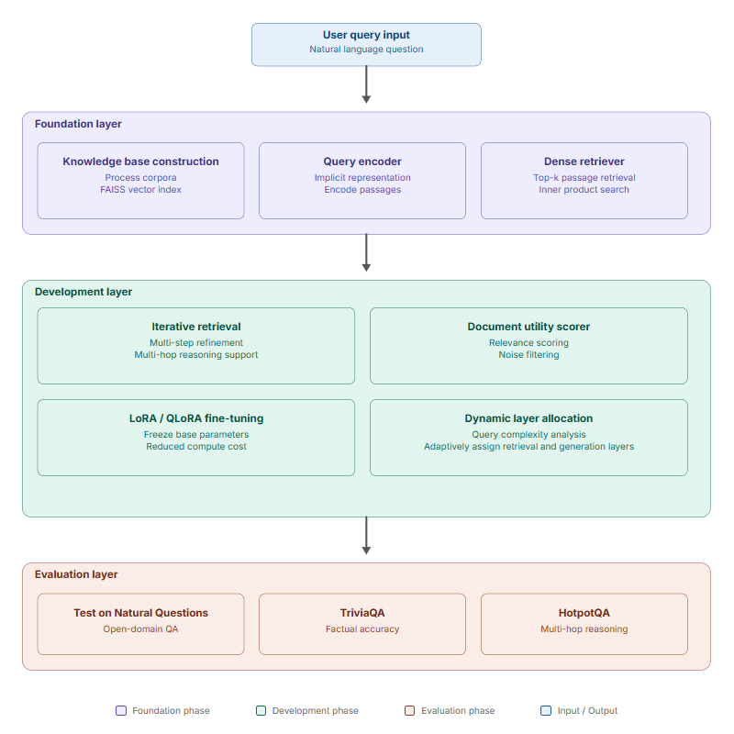
Figure: Three-layer architecture of Adaptive ImpRAG system

1. Data Preparation and Knowledge Base Construction
The first step involves preparing a structured knowledge base as the external information source for retrieval. Documents from publicly available datasets such as Wikipedia or domain-specific corpora are processed and divided into smaller passages. Each passage is encoded using a dense embedding model to create vector representations stored in a vector database. During inference, the retriever compares the encoded query representation with stored document embeddings to identify the most relevant passages.

2. Query Representation and Retrieval
The input query is processed by a query encoder within the language model. Unlike traditional systems, the implicit retrieval approach allows the model to internally represent its information needs without manual query formulation. The encoded query is used by the retriever to search the vector database and retrieve the top-k most relevant document passages using dense retrieval methods.

3. Iterative Retrieval Mechanism
To address single-pass retrieval limitations, the proposed system introduces an iterative retrieval mechanism where the model performs multiple retrieval steps during generation. In each iteration the language model generates intermediate representations based on previously retrieved information, uses these to form refined retrieval queries, and retrieves additional documents. This allows the model to progressively refine its knowledge, which is particularly beneficial for complex multi-hop queries.

4. Document Utility Scoring
Not all retrieved documents contribute equally to the final answer. A document utility scoring module evaluates each retrieved passage based on its semantic similarity to the query and its contribution to the generation context. Documents with higher utility scores are prioritized while irrelevant passages are filtered out, reducing noise and improving response accuracy.

5. Parameter-Efficient Fine-Tuning
To reduce training cost, the framework incorporates LoRA and QLoRA. Instead of updating all model parameters, these methods introduce small trainable matrices while keeping the majority of parameters frozen, significantly reducing computational requirements while maintaining strong model performance.

6. Dynamic Layer Allocation Strategy
The proposed system introduces a dynamic layer allocation mechanism that analyses query complexity and adaptively determines how many layers are dedicated to retrieval versus generation. Simpler queries use fewer layers reducing overhead, while complex queries receive additional layers to improve reasoning and retrieval quality.

7. Improved Retriever Training
Instead of relying on noisy pseudo-labels from external retrievers, the framework incorporates improved supervision using relevance signals derived from large language models and feedback from multiple retriever ensembles, generating higher-quality training labels and improving the retriever's ability to identify useful documents.

8. Response Generation
The filtered and prioritized documents are provided to the language model generator along with the original query. By combining iterative retrieval, document filtering, and adaptive computation, the proposed Adaptive ImpRAG system improves factual accuracy, reduces computational cost, and enhances overall performance on knowledge-intensive tasks.

WORK PLAN

Table: Project Gantt chart showing planned and actual schedules for the nine phases of Adaptive ImpRAG development
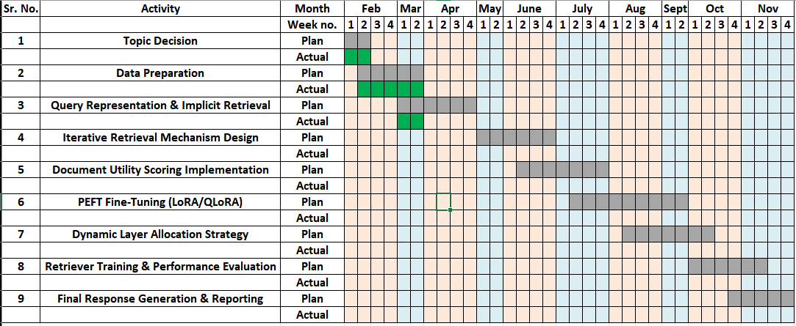

PROJECT OUTCOMES & INDIVIDUAL ROLES

Project Outcomes
Adaptive ImpRAG is expected to significantly improve factual accuracy over baseline RAG systems by incorporating iterative retrieval and document utility scoring. This ensures that only the most relevant and high-quality information contributes to the final response, with performance validated on benchmarks like NaturalQuestions and TriviaQA.
The system also aims to reduce hallucinations by progressively refining retrieved knowledge and filtering out irrelevant or low-quality passages, ensuring outputs remain grounded in reliable external information rather than static model knowledge.
By integrating LoRA and QLoRA, the framework enables more efficient training with drastically fewer parameters, making it practical to deploy on limited hardware without sacrificing performance.
Finally, the multi-step iterative retrieval approach is expected to outperform traditional single-pass retrieval systems on complex multi-hop reasoning tasks such as HotpotQA, where answers require combining information from multiple sources.

Individual Roles
Name | Role | Responsibility
Samyak Rawat | ML Engineer | Design and implement the iterative retrieval mechanism and dynamic layer allocation strategy. Integrate LoRA and QLoRA fine-tuning into the training pipeline.
Saksham Gupta | ML Engineer
Noor Tandon | Data Engineer | Build and manage the knowledge base using large text corpora. Implement passage encoding and set up the FAISS vector database for similarity-based retrieval.
Kunal Gupta | Evaluation Engineer | Design the evaluation framework and run experiments on NaturalQuestions, TriviaQA, and HotpotQA. Conduct studies to measure each component's contribution.
Arshia Anand | Backend Engineer | Develop the end-to-end system pipeline connecting all components. Implement the query encoder and response generation pipeline using PyTorch and HuggingFace.

COURSE SUBJECTS

1. Natural Language Processing
- Language modelling and text generation
- Attention mechanisms and transformer architectures
- Question answering and factual grounding

2. Machine Learning
- Supervised learning and optimization
- Fine-tuning pre-trained models
- Model evaluation and performance metrics

3. Deep Learning
- Transformer architecture and multi-head self-attention
- Encoder-decoder models and layer normalization
- Low-rank adaptation via LoRA and QLoRA

4. Information Retrieval
- Dense retrieval and vector similarity search
- Passage ranking and top-k document retrieval
- Multi-hop retrieval and FAISS vector database

5. Database Management Systems
- Vector database design and management
- Indexing and query optimization
- Embedding storage and retrieval

6. Data Structures and Algorithms
- Search algorithms and efficient indexing
- Graph traversal for multi-hop reasoning
- Complexity analysis and optimization

7. Software Engineering
- Modular system design and Python programming
- API and library integration
- System testing and documentation

8. Probability and Statistics
- Similarity measures and threshold selection
- Precision, recall and F1 score evaluation
- Performance benchmarking and analysis

REFERENCES

[1] H. Joren, J. Zhang, C. Ferng, and A. Taly, "Sufficient Context: A New Lens on Retrieval Augmented Generation Systems," in International Conference on Learning Representations (ICLR), 2025.

[2] P. Lewis, E. Perez, A. Piktus, F. Petroni, V. Karpukhin, N. Goyal, H. Küttler, M. Lewis, W. Tau Yih, T. Rocktäschel, S. Riedel, and D. Kiela, "Retrieval-Augmented Generation for Knowledge-Intensive NLP Tasks," in Advances in Neural Information Processing Systems (NeurIPS), 2020.

[3] W. Zhang et al., "ImpRAG: Retrieval-Augmented Generation with Implicit Queries," arXiv preprint arXiv:2506.02279, 2025. [Online]. Available: https://arxiv.org/abs/2506.02279

[4] E. J. Hu, Y. Shen, P. Wallis, Z. Allen-Zhu, Y. Li, S. Wang, L. Wang, and W. Chen, "LoRA: Low-Rank Adaptation of Large Language Models," in International Conference on Learning Representations (ICLR), 2022.

[5] T. Dettmers, A. Pagnoni, A. Holtzman, and L. Zettlemoyer, "QLoRA: Efficient Finetuning of Quantized LLMs," in Advances in Neural Information Processing Systems (NeurIPS), 2023.

[6] A. Asai, Z. Wu, Y. Wang, A. Salehi, and H. Hajishirzi, "Self-RAG: Learning to Retrieve, Generate, and Critique through Self-Reflection," in International Conference on Learning Representations (ICLR), 2024.

